**Design document**

**1. Introduction**

In this document, a c4 architecture diagram will be presented in order to show the model architecture of this software system.

The C4 model documents the architecture of a software system, by showing multiple points of view that explain the decomposition of a system into containers and components, the relationship between these elements, and, where appropriate, the relation with its users.

**2. C4 architecture diagram**

**Level 1**

The System Context diagram shows the big picture of the software system, being able to see the users and the other systems that interact with it

**Level 2**

The Container diagram shows the high-level shape of the software architecture and how responsibilities are distributed across it. It also shows the major technology choices and how the containers communicate with one another.

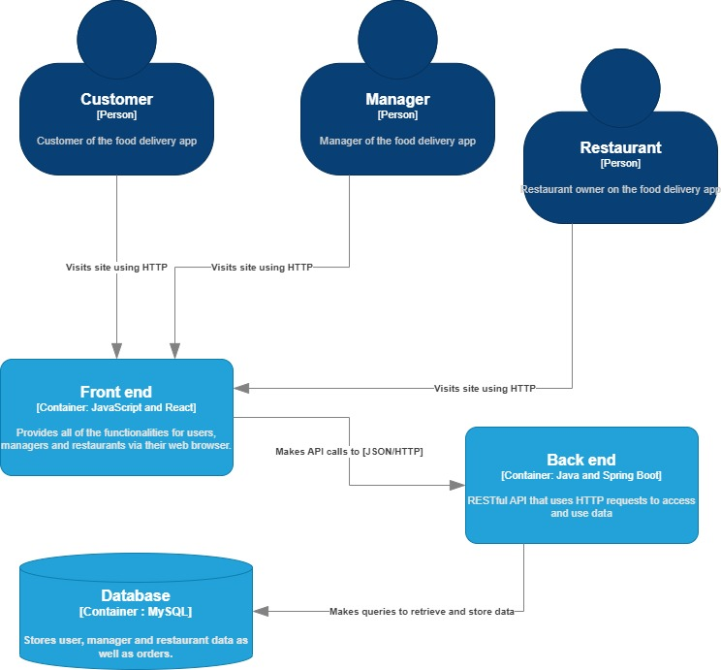

**Level 3**

The Component diagram shows how a container is made up of a number of components, what each of those components are, their responsibilities and the technology/implementation details.

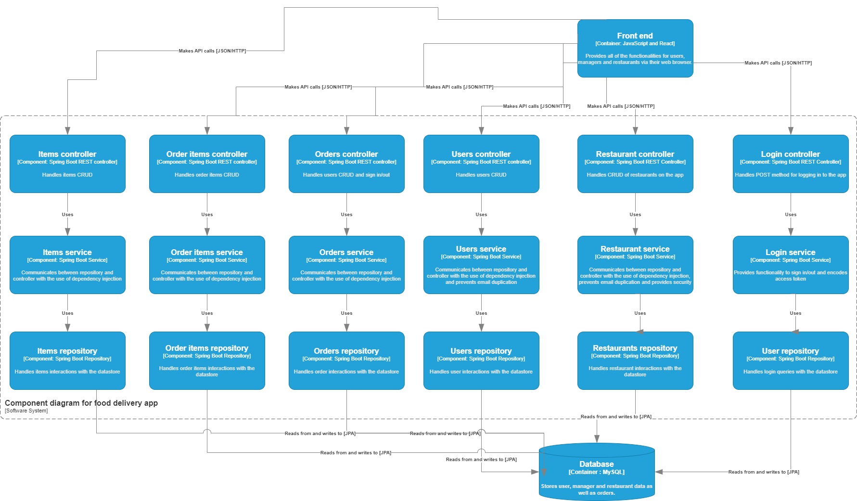

**Level 4**

This UML diagram shows the in depth communication between one of the components.

